IT344 - Applied Dating Mining
Fall 2019
Prof: Dr. Javadi
Jack and Isaac

1 - Information about the dataset

The data is derived from a sample of children ages 3-5 who go through a number of games on PBS Kids Measure Up that test how they react to certain stimuli. These games are presented in puzzle form, and children are ranked according to how quickly they can learn and move on to the next round.

The categories assigned to each child as they go through the games are as follows: 3 for accomplishing the task in one try, 2 for taking a second try, 1 for taking a third, and 0 for any additional. The private test set has approximately 8MM rows.

2 - Explain the evaluation rule

The evaluation rule takes submissions and evaluates them based on the quadratic weighted kappa. It takes the actual and predicted values and measures how well they agree; this metric ranges from 0 (no correlation) to 1 (highly correlated ).

3 - Data Exploration summary

Target: categorical - ordinal
0: never solved
1: solved after 3 or more
2: solved on the 2nd attempt
3: solved on the 1st attempt

Input vars

field | description | Possible use | Other people’s exploration
event_id | Random identifier | Map specific event to randomly generated id | 386 unique ids
game_session | Random identifier | Randomly generates id to determine which game session it is | Same in other notebooks
timestamp | From users machines | Time of the day matters? | Not sure how it relates to time zone  Number of events pick on Thu & Fri
event_data | Lots of info about events | A semi-structured JSON file containing event parameters such as event_count and event_code | What's the most efficient way to parse the event_data column into a DataFrame?
installation_id | Single user (or multiple users sharing the id) | Main identifier | 17K unique ids  50K+ events per id  Look at median  We may want to do separate models on users with High, Med, and Low event counts
event_count | Incremental counter of events within a game session (offset at 1). Extracted from event_data. | We can calculate the sum of event_count
event_code | Events within a game such as start, end, …. | They may be combined with the game to be a predictor? | 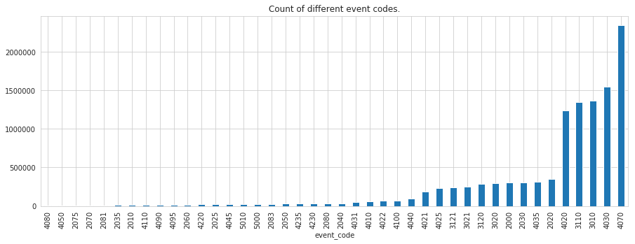  About 40 unique values, don’t know what they mean  Work on identifying meanings
game_time | In milliseconds, show the time elapsed since the start of the game | Longer, possibility of misses increases? Kid tired? | Log transformations are normal
title | Title of the game or video. | What games do they like most?  What is the relationship between title and difficult level (or other attributes) | Chow Time is very popular, along with Sandcastle Builder, Scrub-A-Dub, and Bottle Filler  Games with levels are less frequent
type | Media type of the game or video. Possible values are: 'Game', 'Assessment', 'Activity', 'Clip'. | What type of games that kids like more? | Most are games, next are activities  Clips are the least common
world | The section of the application the game or video belongs to.  Helpful to identify the educational curriculum goals of the media. Possible values are: 'NONE' (at the app's start screen), TREETOPCITY' (Length/Height), 'MAGMAPEAK' (Capacity/Displacement), 'CRYSTALCAVES' (Weight). | What type of world that kids like more? | 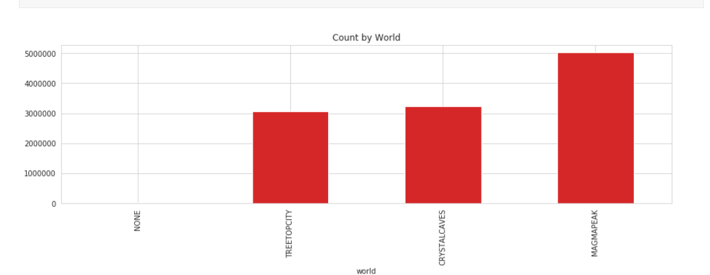

4 - Data preparation and the changes made to the data

One technique being used in the data preparation process is data minification. It is the process of removing all unnecessary characters from the data without changing or losing the data itself. Also, the data is huge. It has 17.000 labels for 11 million data points (train data). Converting time to a useable form is also one of the processes in the data preparation.

Function of data minification (credit: Pradeep Muniasamy):

def reduce_mem_usage(df):
start_mem_usg = df.memory_usage().sum() / 1024**2
print("Memory usage of properties dataframe is :",start_mem_usg," MB")
NAlist = [] # Keeps track of columns that have missing values filled in.
for col in df.columns:
if df[col].dtype != object: # Exclude strings

# make variables for Int, max and min
IsInt = False
mx = df[col].max()
mn = df[col].min()

#Integer does not support NA, therefore, NA needs to be filled
if not np.isfinite(df[col]).all():
NAlist.append(col)
df[col].fillna(-999,inplace=True)

# test if column can be converted to an integer
asint = df[col].fillna(0).astype(np.int64)
result = (df[col] - asint)
result = result.sum()
if result > -0.01 and result < 0.01:
IsInt = True

# Make Integer/unsigned Integer datatypes
if IsInt:
if mn >= 0:
if mx < 255:
df[col] = df[col].astype(np.uint8)
elif mx < 65535:
df[col] = df[col].astype(np.uint16)
elif mx < 4294967295:
df[col] = df[col].astype(np.uint32)
else:
df[col] = df[col].astype(np.uint64)
else:
if mn > np.iinfo(np.int8).min and mx < np.iinfo(np.int8).max:
df[col] = df[col].astype(np.int8)
elif mn > np.iinfo(np.int16).min and mx < np.iinfo(np.int16).max:
df[col] = df[col].astype(np.int16)
elif mn > np.iinfo(np.int32).min and mx < np.iinfo(np.int32).max:
df[col] = df[col].astype(np.int32)
elif mn > np.iinfo(np.int64).min and mx < np.iinfo(np.int64).max:
df[col] =df[col].astype(np.int64)

# Make float datatypes 32 bit
else:
df[col] = df[col].astype(np.float32)

# Print final result
print("___MEMORY USAGE AFTER COMPLETION:___")
mem_usg = df.memory_usage().sum() / 1024**2
print("Memory usage is: ",mem_usg," MB")
print("This is ",100*mem_usg/start_mem_usg,"% of the initial size")
return df,NAlist

The function used to convert time to a useable form is demonstrated in step 5.

5 - Major Models re-used

The function we used, we decided is actually part of the data preparation as well. It takes data from time values and converts it into more useable formats.

def extract_time_features(df):
df['timestamp'] = pd.to_datetime(df['timestamp'])
df['date'] = df['timestamp'].dt.date
df['month'] = df['timestamp'].dt.month
df['hour'] = df['timestamp'].dt.hour
df['year'] = df['timestamp'].dt.year
df['dayofweek'] = df['timestamp'].dt.dayofweek
df['weekofyear'] = df['timestamp'].dt.weekofyear
df['dayofyear'] = df['timestamp'].dt.dayofyear
df['quarter'] = df['timestamp'].dt.quarter
df['is_month_start'] = df['timestamp'].dt.is_month_start

return df

As you can see, after extracting the time values, we now can break the time of the event all the way down to the day of the event.

6 - Metrics used for evaluating model performance on training data set

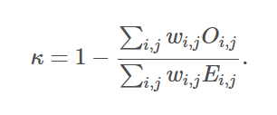The model is evaluated based on the quadratic weighted kappa, as shown above. The evaluation score we are given is based off of the submission file, which takes each installeion_id and comes up with the score (accuracy_group) based off of the agreeableness of the predicted and actual values This measures agreement levels between predicted and actual outcomes which are related in the 0-3 scoring method that was elaborated on previously.

7 - Unique model

The CatBoostClassifier package is used to make predictions in the model. The parameter were configured by using the documentation from https://catboost.ai/docs/concepts/python-reference_catboostclassifier.html

In this model, we set early_stopping_rounds, which helps avoid overfitting, to 800 to ensure that we had enough iterations. We also made random_seed 37. The following is one of the code chunks that was being customized:

def make_classifier(iterations=6000):
clf = CatBoostClassifier(
loss_function='MultiClass',
eval_metric="WKappa",
task_type="CPU",
iterations=iterations,
od_type="Iter",
early_stopping_rounds=800,
random_seed=37,
)

return clf

Also, the KFold class is used to split the dataset in 10 different training and validation sets. Additionally, we decided we wanted ids to be outputted as sorted, so we changed sorted from false to true.

Two scores = two experimentations - two scores - one parameter that deals with bias.

